IT24102268

Ps -lab 05

1) 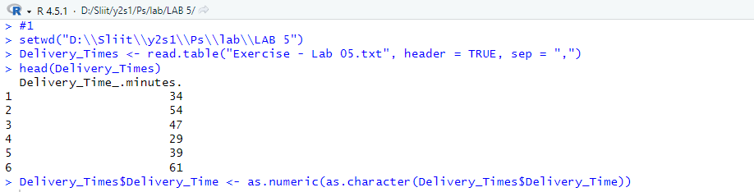

2)

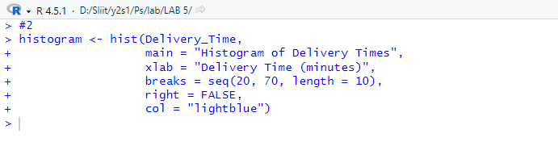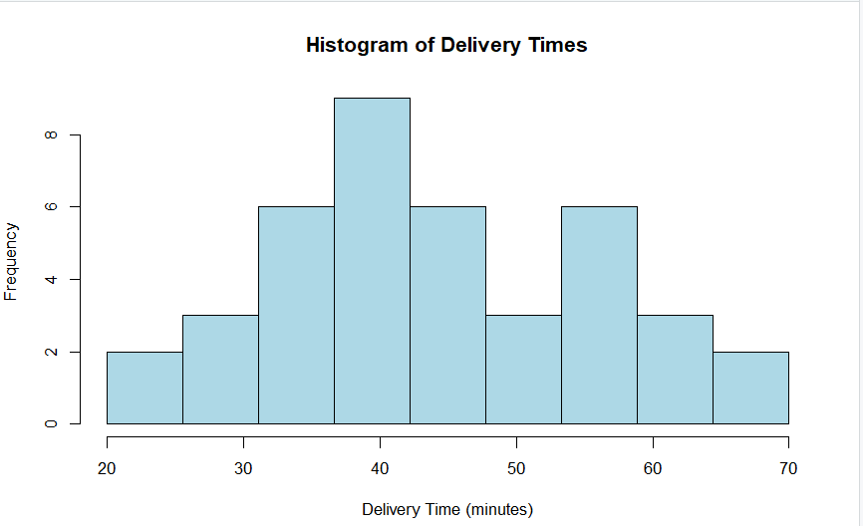3)

The distribution appears to be approximately symmetric with a slight right skew.

Most delivery times are clustered between 35-55 minutes.

4) 